Title: Achieving Health Care Equity: identifying our Resources, Challenges, and Next Steps
Authors:
Lesley Cottrell PhD¹, Kathy Sheppard-Jones PhD², Caroline Gooden PhD², Fred Biasini PhD³, Jordan Kerr BSPH⁴, Tanisha Clarke MPH⁴, Adriane K. Griffen DrPH, MPH, MCHES⁴

¹ West Virginia University, Department of Pediatrics & Center of Excellence on Disabilities; ² University of Kentucky Human Development Institute and Department of Early Childhood, Special Education and Counselor Education, ³ Alabama University Center of Excellence in Developmental Disabilities; ⁴ Association of University Centers on Disabilities

Abstract:
Efforts to reduce health care disparities have focused on the need for tool, guidelines, and training materials that would increase accessibility of preventive and treatment options to everyone. Yet disparities continue to exist noting a continued need to focus on effective programming that would increase awareness that the disparities exist and tools to reduce them over time in various settings. The purpose of this study was to highlight multi-state efforts designed to collaborate with health care providers and provide different forms of training that would be effective at reducing factors associated with health disparities for individuals with disabilities. These initiatives are diverse in terms of their audience and approach. We highlight details about their implementation and note experiences (challenges and potential solutions) associated with implementation and effectiveness including COVID-19.

Background:
- The largest health care consumer group in the United States is made up of individuals with at least one disability. Yet this group tends to have poorer health outcomes at a rate that is significantly higher than people who do not have disabilities (refs).
- Health care disparities have been documented consistently for various groups
  - Women with significant disabilities are more likely to have fewer cancer screenings and preventive tests than women who do not have disabilities (refs)
  - Adults who are deaf are 3X more likely to report poorer health (refs)
- Health disparities researchers have highlighted factors including: having limited to no resources that aid in one’s understanding (interpreter services, materials), physical barriers within practice, provider knowledge about health disparity and needs, limited consideration of contextual factors that could impact patient compliance.
- Efforts to reduce health disparities are ongoing; helpful products for providers and others are increasingly becoming available

Purpose of Overview:
The purpose of this study was to highlight multi-state efforts within the UCEDD network that were designed and coordinated within AUCD’s HEAT Initiative to collaborate with health care providers and provide different forms of training that would be effective at reducing factors associated with health disparities for individuals with disabilities.

Methods:

Participating Institutions and Initiatives:
University of Alabama at Birmingham: Health is for Everyone
University of Kentucky: Teaching and Learning Initiatives
West Virginia University: Not Your Standard Patient and Project DOCC

Procedures:
The HEAT Initiative met quarterly during the proposed period. Participating institutions were at various stages with their health disparities initiatives. Each continued to develop, implement, evaluation, and/or sustain initiatives during an 18-month period from 2018-2020. Team meetings included a review of current activities, planned activities in the next quarter, challenges experienced to date, proposed solutions, and if attempted, success of efforts to combat challenges.

Initiative Overview:

 | Health is for Everyone | Teaching & Learning Initiatives | Not Your Standard Patient | Project DOCC
Overall Goal | Increase medical student knowledge and comfort providing services to children with special health care needs and their families. | University students taking courses in medicine and healthcare will report increased knowledge on topics related to disability and inclusion as a result of participating the Human Development Institute’s University Lecture Series during the 2019-2020 academic year. | Health sciences students will increase their awareness of disability services, increase their person-centered care and people first language, and incorporate disability considerations in their clinical approach. | Health sciences students and families will discuss family experiences with clinical care to increase their knowledge of family-centered medical home.
Focus | Incorporate increased focus on disability services, service coordination, and developmental approaches within the medical school curriculum. | Disability transitions, development, and coordination of care | Etiquette and visit impressions | Patient-centered medical home
Learners | University third year medical students in Pediatrics and Family Medicine | University students and medical residents | Undergraduate medical students | pharmacy, medicine, nursing, students and medical residents.
Facilitators | UAB medical faculty | HDI staff | WVU faculty; simulation center team | 5 faculty mentors and 5 family mentors
Procedures | Work with rotation coordinators for pediatrics and family medicine to provide a one week curriculum focused on:  - Development  - Special health care needs  - Disability services | A catalog of 37 one-hour offerings was developed and marketed. Course catalog is available at: https://hdi.uky.edu/university-lecture-series 29 Lectures/rotations offered  As part of HDI University Lecture series and Medical Resident Rotation with HDI  - Disability Resources in KY  - Disability Awareness Training Ableism  - Early Childhood Transitions  - Early Childhood Assessment Instruments  - Getting Comfortable with Disability  - Assistive Technology  - Sexuality and Disability  - Community Engagement  - Road map for Inclusion  - HDI Research and Educational Opportunities for UK Students  - Rural Rehabilitation and Access to Health Care  - Allyship  - Universal Design  - Universal Design and Social Stories  - Parenting a Child with a Disability  - Universal Design and Including People with Disabilities in Education | Learners receive information on etiquette, Person First, and other materials prior to simulation through on-line module  Learners are randomized to receive information from the following activities in a different order: panel member discussion, and 3 case scenarios with patient actors  Group discussion closed the session to review interactions, next steps, and overall considerations | Faculty and parent mentors were identified for each session scheduled  Learners receive information on patient-centered medical home model and person first language by on-line module  Baseline assessments completed prior to simulation  Video showcasing families with children with special health care needs shown at the beginning of the simulation  Learners randomized to three breakout rooms to meet and ask questions of parent mentors  Group discussion reviewed standard elements of patient-centered medical home
Setting | Classroom | University and Child Development Center of the Bluegrass |  | WV Steps Center and WVCED
Delivery approach | F2F | F2F and virtually |  | F2F and virtually

Results:

 | Health is for Everyone | Teaching & Learning Initiatives | Not Your Standard Patient | Project DOCC
Stage in Development | D/P | I/E | I/E | I/E
# stakeholders involved | -- | 736 | 26 | 452
Note: D = Development; P = Planning; I = implemented; E = evaluated

Challenges:

- COVID-19 led to shift to virtual delivery of lectures and materials.
- During the development stage, discussions often shifted to not having space within the curriculum for an additional topic.
- Faculty and administrators needed to decipher how the new course or activity fit within their established curriculum and met established accreditation guidelines.
- Meetings with College of Medicine faculty were cancelled in the spring, 2020 semester as a result of COVID.

Solutions that Worked in these Scenarios:
- Discuss and offer previous training and other experience offering accessible learning (face-to-face or virtual).
- Offer multiple events and opportunities during semesters (including summer months) for the initial trial. Other options may arise once they have experienced the initiative directly.
- Consider offering these initiatives as Interprofessional Education (IPE) experiences across various health sciences schools. This is an increasing interest among accreditation boards and often provides more than one contact/support person for the initiative.
- Additional connections within the college or school from other revenues (grants, community service programs, research led to additional opportunities to incorporate learners over time

Conclusions:

- While COVID transitioned all initiatives to virtual format, learners were more comfortable with this format and it could be more easily woven into the curriculum than those that required on-site learning.
- Families (if involved) also enjoyed the virtual format in that it reduced the need for them to travel to the university and offered more of their time for other sessions as a result.
- Now is an ideal time to convey the importance of including disability in medical curricula as there is increased awareness and understanding of environmental factors that are disabling us all.

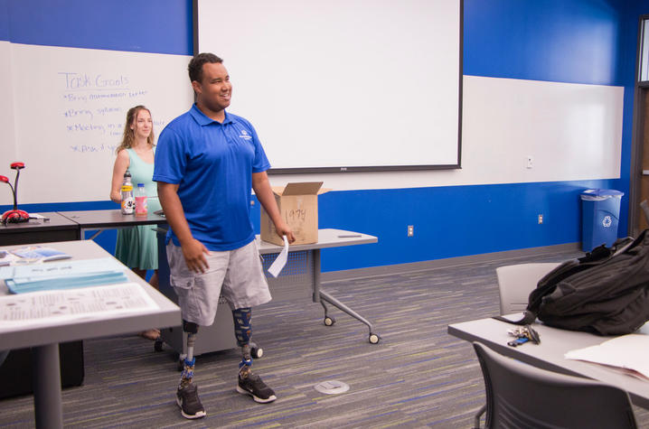
University of Kentucky

*Brian- insert previous photo of classroom view from Project DOCC Walk in our SHoes poster here

